JDBC
____________________________________________________________________________________
JDBC – Java Database Connectivity called as JDBC
Basically it is API design by java which help us to connect your java program with database
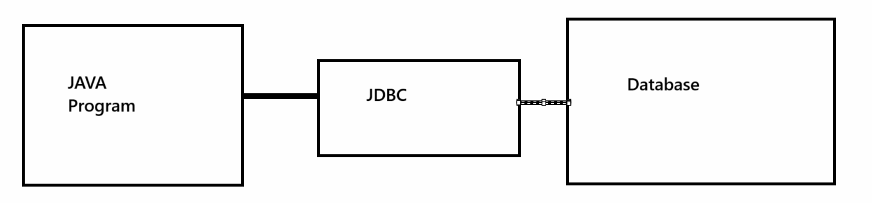

Steps to work with JDBC
___________________________________________________________________
1. Add java.sql package in application
______________________________________________________________
import java.sql.*;
Note: because in this package contain all classes and interfaces related with database connectivity

2. Load driver:
Q. what is driver?
_______________________________________________________________________
Driver is the some inbuilt classes which contain all logics or specify protocols which help us to provide communication between java application and database application.

Types of driver in JDBC
__________________________________________________________
a) Type1
b) Type 2
c) Type3
d) Type 4
Type1 driver is ODBC driver here ODBC stands Open Database Connectivity basically ODBC is a concept launch by Microsoft which is capable for connect your java application with any other database application.
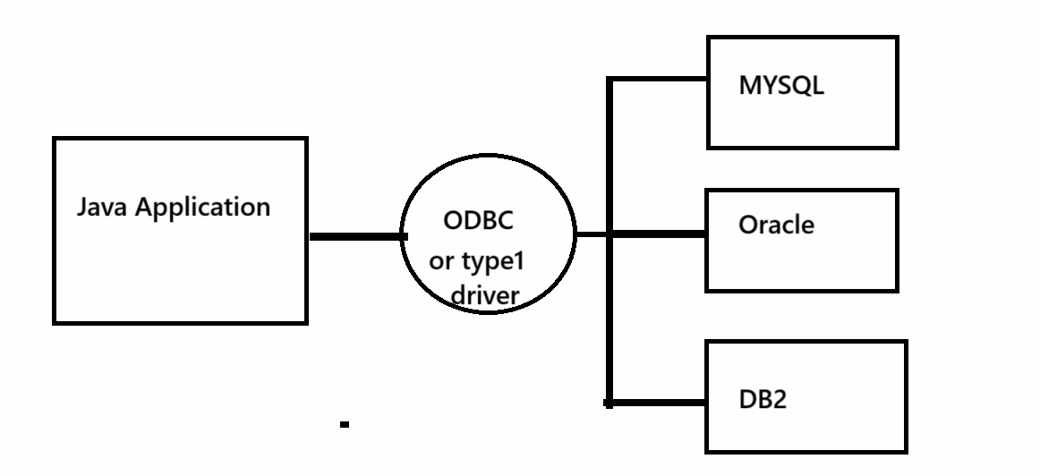
Note: Type1 driver removed by java from JDK 1.8 version

Q. Why Java removed type1 driver?
__________________________________________________________________________
a) Type1 driver design using C /C++ so this is platform dependent driver means this driver only works with window operating system not other
b) Type1 driver not support to network application means you cannot connect remote database using type1 driver so java removed it.
Note: before JDK 1.8 if we want to use type1 driver we have inbuilt class provided by JDK to us name as
sun.jdbc.odbc.JdbcOdbcDriver here sun.jdbc.odbc is package and JdbcOdbcDriver is class name
so if we want to use this type before JDK 1.8 we required to import package name as sun.jdbc.odbc and create object of JdbcOdbcDriver class

Syntax: import sun.jdbc.odbc.*;
JdbcOdbcDriver jd = new JdbcOdbcDriver();

Now we want to discuss about type4 driver

Type4 driver is vendor specific driver here vender consider as database like as oracle,mysql are the vendors etc
Type4 driver is vendor specific driver means a database specific driver means every database has different type4 driver class and this class design by database vendor and provides to us in the form of .jar file

Q. What is .jar file?
_________________________________________________________________________
.jar stands for java archive file basically this .jar work as library in the case of java means if we want to use any API in java we get API in the form of classes and interfaces as well as in the form of methods and members present under the different packages and packages present under .jar and .jar contain only classes
So basically if we want to reuse any API using java we have way known as .jar
So if we want to connect your java program with MYSQL database we required to use mysqlconnector.jar file means you have to download this .jar file and use in application
Use following link for download the .jar file
https://jar-download.com/download-handling.php

If we download the mysqlconnector.jar file then we get one inbuilt class provided by MYSQL and work as driver class known as com.mysql.cj.jdbc.Driver. Here com.mysql.cj.jdbc is package and Driver is classname Here com.mysql.cj.jdbc is package and Driver is class so we want to use this driver we can create its object.
Syntax: com.mysql.cj.jdbc.Driver ref = new com.mysql.cj.jdbc.Driver();

Once we create driver we can register this driver with your application and for that we have class name as DriverManager.registerDriver(Driver);

Syntax: DriverManager is class name and registerDriver() is a static method of DriverManager class and this method can accept reference of Driver interface from java.sql package

Q. Who is Driver interface from java.sql package?
____________________________________________________________________________
Driver is interface from java.sql package and which is implemented by All types of driver classes.
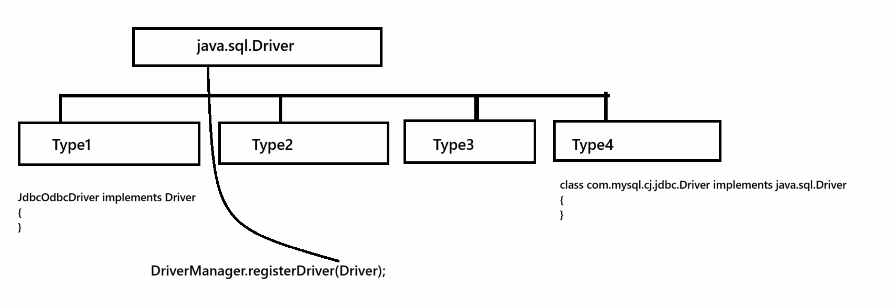
If we think about above method name as DriverManager.registerDriver(Driver) means this method can accept any kind of driver object and register with java application

Steps to add .jar in eclipse and use in application
__________________________________________________________________________
Steps to connect java application with mysql database
_________________________________________________________________________
a) Open eclipse
b) Download the MYSQL connector.jar
c) Create Java Project
d) Add download .jar in eclipse project
Steps to add .jar in eclipse
Right click on JRE System library ---- select build path --- select configure build path --- select class path --- click on add external jar --- select .jar from its stored location ---- click on open button --- click on apply and close button then we get new option name as referenced jar and in this option your jar is present shown in following screen shot
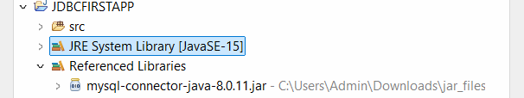
Once we add this .jar in your project then we can register your driver with java program
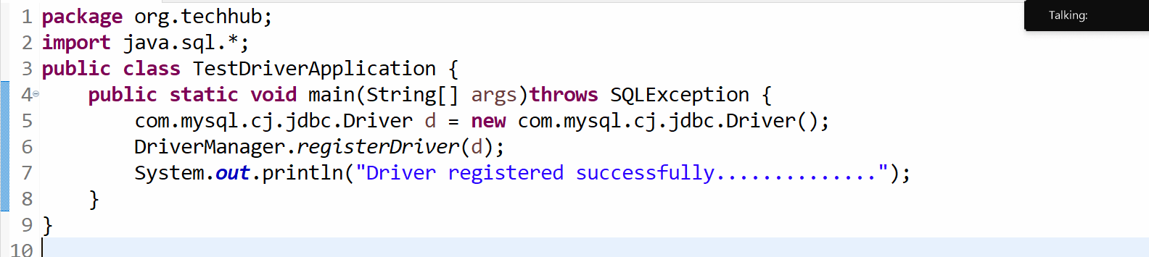
Note: After JDK 1.5 version of java if we not register driver just add .jar file then JVM detect Driver automatically according to .jar

3. Establish connection: if we want to establish the connection with a database we have Connection interface and if we want to create reference of Connection interface we have getConnection() method of DriverManager class.
Syntax: Connection ref = DriverManager.getConnection(String url,String username,String password);
String url: this parameter indicate the path of database means in URL we specify protocol, database name and port number of database server
String username: here we specify the username of database which we provide at the time of database installation
String password: here we specify the password of database which we provide at the time of database installation

Note: When we work with MYSQL then your URL like as jdbc:mysql://localhost:portnumber/databasename
Example: jdbc:mysql://localhost:3306/febmarchmay

URL Description

jdbc:mysql is protocol for establish connection between Java and MYSQL database
localhost or ipaddress is location where your database is present if we use localhost means database is present where java code is present means java program and database present on same machine and if your java code present on different machine and database present on different machine then you have to specify ip address of machine in URL where database is present.
3306 is default port number of MYSQL and user can change the port number according to his requirement at the time of installation and febmarchmay is database name

Sample code of database connection is
__________________________________________________________________________________
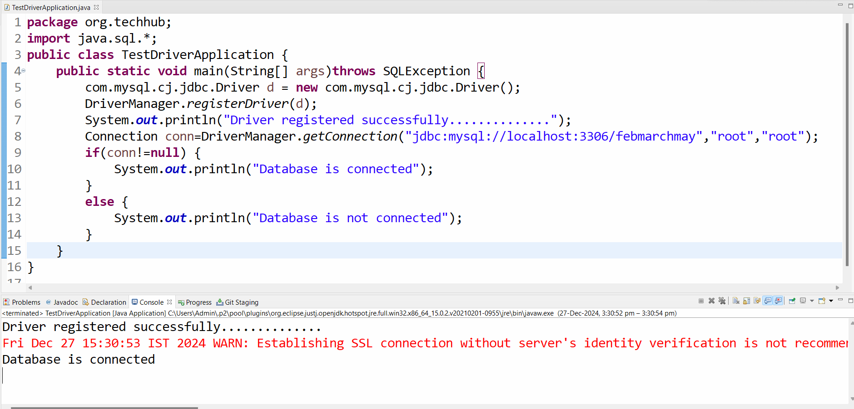

Once we connect your java application with database application then we can work with database and for that we have some following interfaces given below

4. Work with Database
a) Statement
b) PreparedStatement
c) ResultSet
d) CallableStatement
e) ResultSetMetaData
f) DatabaseMetaData
g) Blob
h) Clob
etc

Statement interface
___________________________________________________________________________________
Statement is interface from java.sql package which is used for perform all DDL and DML operation on database like as using Statement interface we can perform insert/delete/update/select operation on database.
Steps to work with Statement interface
__________________________________________________________________________________
a) Add java.sql package in application
import java.sql.*;

b) Create reference of Statement interface
________________________________________________________________________________
If we want to create reference of Statement interface we have createStatement() method of Connection and this method return reference of Statement interface to us
Syntax: Statement ref = connref.createStatement();

Sample code
package org.techhub;
import java.sql.*;
public class TestDriverApplication {
public static void main(String[] args)throws SQLException {
com.mysql.cj.jdbc.Driver d = new com.mysql.cj.jdbc.Driver();
DriverManager.registerDriver(d);
System.out.println("Driver registered successfully..............");
Connection conn=DriverManager.getConnection(“jdbc:mysql://localhost:3306/febmarchmay”,”root”,”root”);
if(conn!=null) {
System.out.println(“Database is connected”);
Statement stmt=conn.createStatement();
}
else {
System.out.println(“Database is not connected”);
}
}
}

c) Use its executeUpdate() and executeQuery() method
_____________________________________________________________________
int executeUpdate(String sqlStatement): this method can execute the all DDL and DML operation except select and if operation executed successfully return 1 otherwise return 0.
ResultSet executeQuery(String sqlQuery): this method can execute only select query and fetch its data and store in ResultSet reference.

Example for insert record in database table
package org.techhub;
import java.sql.*;
public class TestDriverApplication {
public static void main(String[] args)throws SQLException {
com.mysql.cj.jdbc.Driver d = new com.mysql.cj.jdbc.Driver();
DriverManager.registerDriver(d);
System.out.println("Driver registered successfully..............");
Connection conn=DriverManager.getConnection("jdbc:mysql://localhost:3306/febmarchmay","root","root");
if(conn!=null) {
System.out.println("Database is connected");
Statement stmt=conn.createStatement();
int value=stmt.executeUpdate("insert into employee values('0','shyam',20000)");
if(value>0) {
System.out.println("Record save successfully.............");
}
else {
System.out.println("Some problem is there....................");
}
}
else {
System.out.println("Database is not connected");
}
}
}

How to delete record from database using its id.
_________________________________________________________________________________
package org.techhub;
import java.sql.*;
public class TestDriverApplication {
public static void main(String[] args)throws SQLException {
com.mysql.cj.jdbc.Driver d = new com.mysql.cj.jdbc.Driver();
DriverManager.registerDriver(d);
System.out.println("Driver registered successfully..............");
Connection conn=DriverManager.getConnection("jdbc:mysql://localhost:3306/febmarchmay","root","root");
if(conn!=null) {
System.out.println("Database is connected");
Statement stmt=conn.createStatement();
int value=stmt.executeUpdate("delete from employee where id=1");
if(value>0) {
System.out.println("Record Deleted successfully.............");
}
else {
System.out.println("Some problem is there....................");
}
}
else {
System.out.println("Database is not connected");
}
}
}
How to update using JDBC
package org.techhub;
import java.sql.*;
public class TestDriverApplication {
public static void main(String[] args)throws SQLException {
com.mysql.cj.jdbc.Driver d = new com.mysql.cj.jdbc.Driver();
DriverManager.registerDriver(d);
System.out.println("Driver registered successfully..............");
Connection conn=DriverManager.getConnection("jdbc:mysql://localhost:3306/febmarchmay","root","root");
if(conn!=null) {
System.out.println("Database is connected");
Statement stmt=conn.createStatement();
int value=stmt.executeUpdate("update employee set name='shyama',salary=50000 where id=2");
if(value>0) {
System.out.println("Record Updated successfully.............");
}
else {
System.out.println("Some problem is there....................");
}
}
else {
System.out.println("Database is not connected");
}
}
}

Now we want to accept the name and salary from keyboard and store in database table
_____________________________________________________________________________
package org.techhub;
import java.sql.*;
import java.util.*;
public class TestDriverApplication {
public static void main(String[] args)throws SQLException {
com.mysql.cj.jdbc.Driver d = new com.mysql.cj.jdbc.Driver();
DriverManager.registerDriver(d);
System.out.println("Driver registered successfully..............");
Connection conn=DriverManager.getConnection("jdbc:mysql://localhost:3306/febmarchmay","root","root");
if(conn!=null) {
Scanner xyz = new Scanner(System.in);
System.out.println("Enter name and salary from keyboard");
String ename=xyz.nextLine();
int esal=xyz.nextInt();
System.out.println("Database is connected");
Statement stmt=conn.createStatement();
int value=stmt.executeUpdate("insert into employee values('0','ename',esal)");
if(value>0) {
System.out.println("Record inserted successfully.............");
}
else {
System.out.println("Some problem is there....................");
}
}
else {
System.out.println("Database is not connected");
}
}
}
Output
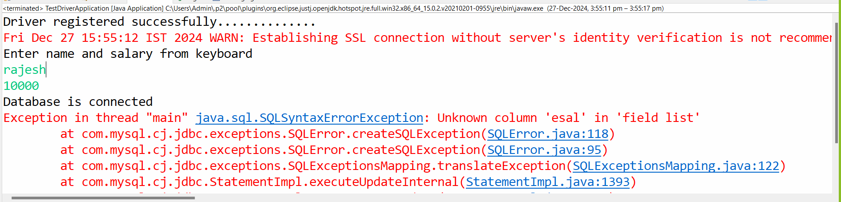
Note: if we think about above code we accept the name and salary from keyboard and pass variable as parameter as run time value to SQL query but if we think about statement interface we cannot pass variable as sql statement value directly in java code for that we required to use SQL Injection technique.

Q. What is SQL Injection?
SQL injection is technique where we separate the java variable from SQL query by using “”+

Example with SQL Injection
package org.techhub;
import java.sql.*;
import java.util.*;
public class TestDriverApplication {
public static void main(String[] args)throws SQLException {
com.mysql.cj.jdbc.Driver d = new com.mysql.cj.jdbc.Driver();
DriverManager.registerDriver(d);
System.out.println("Driver registered successfully..............");
Connection conn=DriverManager.getConnection("jdbc:mysql://localhost:3306/febmarchmay","root","root");
if(conn!=null) {
Scanner xyz = new Scanner(System.in);
System.out.println("Enter name and salary from keyboard");
String ename=xyz.nextLine();
int esal=xyz.nextInt();
System.out.println("Database is connected");
Statement stmt=conn.createStatement();
int value=stmt.executeUpdate("insert into employee values('0','"+ename+"',"+esal+")");
if(value>0) {
System.out.println("Record inserted successfully.............");
}
else {
System.out.println("Some problem is there....................");
}
}
else {
System.out.println("Database is not connected");
}
}
}

How to select data from a database table Using Statement
_______________________________________________________________________________
If we want to select record from a database table using JDBC we can use executeQuery() method of Statement interface and this method can return reference of ResultSet interface.

Syntax: ResultSet executeQuery(String selectStatement);

Q. What is ResultSet?
__________________________________________________________________________
ResultSet is a interface from java.sql package which is able store data fetch by select query and provide some inbuilt method to us which help us to fetch data from ResultSet interface reference.
Methods of ResultSet interface
_____________________________________________________________________________
boolean hasNext(): this method can check record present in database table or not if present return true otherwise return false.

String getString(String columnName): this method is used for fetch varchar type of data from a database table using its column name.

String getString(int index): this method can fetch data from table using its index and index start from 1

Important points
________________________________________________________________________
if we use * in select query then first column of table has 1st index upto n
Example: suppose consider we have table name as register with column
rid name email contact
if we execute query like as
select *from register;
Here rid has 1st index ,name has 2nd ,email has 3rd index and contact has 4th index

Suppose consider we have execute the query like as
select contact,name,email from register;

here contact has 1st index even it is 4th column in table , name has 2nd index even it is 2nd column and so on mean in partial selection index allocation technique is first in first out from left to right.

int getInt(String columnName): this function can return integer value using its column name
int getInt(int index):this function can return integer value using its column index

float getFloat(String columnName): this function can return float type of value using its column name
float getFloat(int index): this function can return float type of value using its index.

double getDouble(int index): this function can return double type of value using its column index
double getDouble(String columnName);

long getLong(int index):
long getLong(String columnName);
etc

Example: WAP JDBC code to fetch data from database table
package org.techhub;
import java.util.*;
import java.sql.*;
public class FetchDataApplication {
public static void main(String[] args)throws SQLException {

com.mysql.cj.jdbc.Driver d=new com.mysql.cj.jdbc.Driver();
DriverManager.registerDriver(d);
Connection conn=DriverManager.getConnection("jdbc:mysql://localhost:3306/febmarchmay","root","root");
if(conn!=null) {
Statement stmt=conn.createStatement();
ResultSet rs=stmt.executeQuery("select *from employee");
while(rs.next()) {
/* fetch data using index
* int empid=rs.getInt(1);
String name=rs.getString(2);
int sal=rs.getInt(3);
System.out.println(empid+"\t"+name+"\t"+sal);
*/
int empid=rs.getInt("id");
String empname=rs.getString("name");
int empsal=rs.getInt("salary");
System.out.println(empid+"\t"+empname+"\t"+empsal);
}
}
else {
System.out.println("Database is not connected");
}

}
}

Example: WAP to fetch employee detail by using its id and name
package org.techhub;
import java.sql.*;
import java.util.*;
public class EmployeeWithWhereApp {
public static void main(String[] args) throws SQLException {
com.mysql.cj.jdbc.Driver d = new com.mysql.cj.jdbc.Driver();
DriverManager.registerDriver(d);
Connection conn = DriverManager.getConnection("jdbc:mysql://localhost:3306/febmarchmay", "root", "root");
if (conn != null) {
Scanner xyz = new Scanner(System.in);
System.out.println("Enter name and id of emplyee");
String empname = xyz.nextLine();
int empid = xyz.nextInt();
Statement stmt = conn.createStatement();
ResultSet rs = stmt.executeQuery("select *from employee where id=" + empid + " and name='" + empname + "'");
if (rs.next()) {
System.out.println("Data found");
} else {
System.out.println("Data not found");
}
} else {
System.out.println("Database is not connected");
}
}

}

PreparedStatement interface
________________________________________________________________________________
PreparedStatement interface is used for perform All DML operation like as Statement interface
Means using PreparedStatement we can insert record in database table, delete record from database table or update record in database table or select record from database table etc

Q. Why use PreparedStatement interface if we have Statement interface is present?
______________________________________________________________________________
a) If we use the Statement interface and if we want to pass run time parameter to SQL Statement then we need to manage SQL Injection and SQL Injection is responsible for to leak the data or not secure way
And if we use the PreparedStatement and if we want to pass run time parameter then we not need to manage SQL injection you can pass run time parameter to SQL Query without SQL injection
b) PreparedStatement indicate it is precompiled statement means when we execute same query multiple time using PreparedStatement then complete Query not executed by database engine just update its parameter and statement can execute whole query every time.

How to work with PreparedStatement interface
_______________________________________________________________________________
a) Add java.sql package in application
import java.sql.*;
b) Create reference of PreparedStatement interface
______________________________________________________________________
If we want to create reference of PreparedStatement interface we have prepareStatement() method of Connection interface.
Syntax:
PreparedStatement ref = connref.prepareStatement(String sqlStatement);
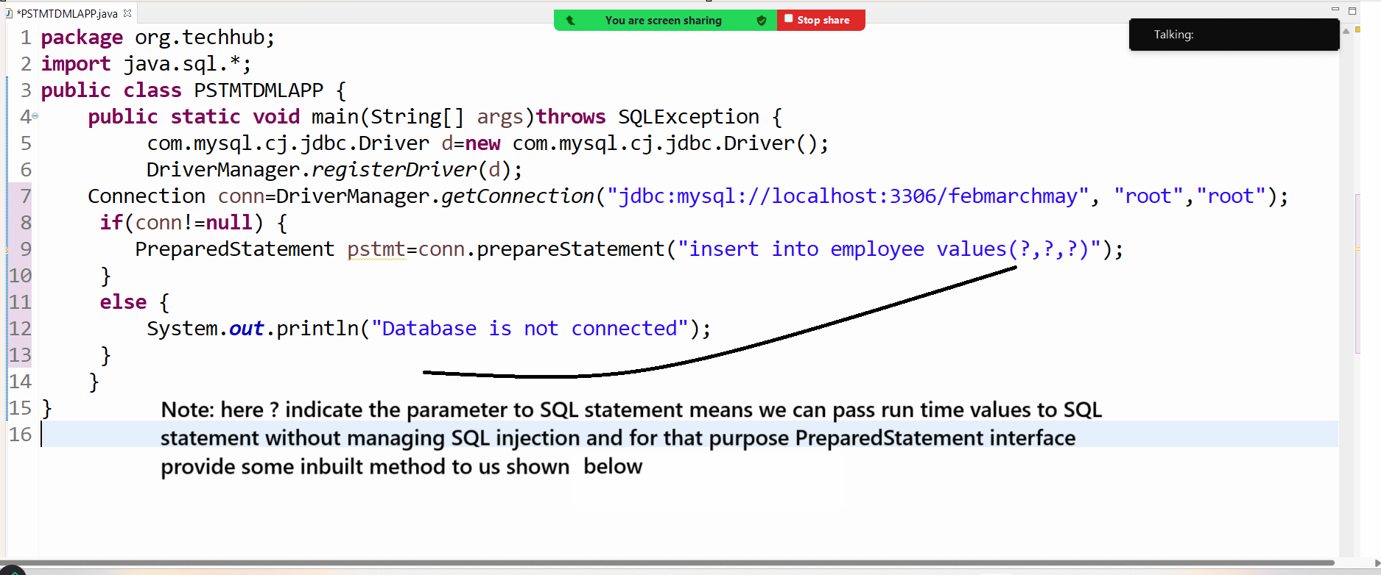
Methods of PreparedStatement interface
_______________________________________________________________________________
void setInt(int index,int data): this method is used for pass integer type of data to SQL statement using its index and index start from 1 and first ? in SQL statement consider as first index.
void setString(int index,String data): this method is used for pass string type of data to SQL statement using its index
void setLong(int index,long data): this method is used for pass long type of data to SQL statement
void setShort(int index,short data): this method is used for pass short type of data to SQL Statement
void setByte(int index,byte data): this method can pass small type of int data to sql statement
void setBinaryStream(int index,InputStream,int length): this method can pass input stream data or binary format data to SQL statement like as image,audio,video etc
void setCharacterStream(int index,Reader,int int length): this method can pass text format data to SQL statement like as store notepad file or document file in database table
etc
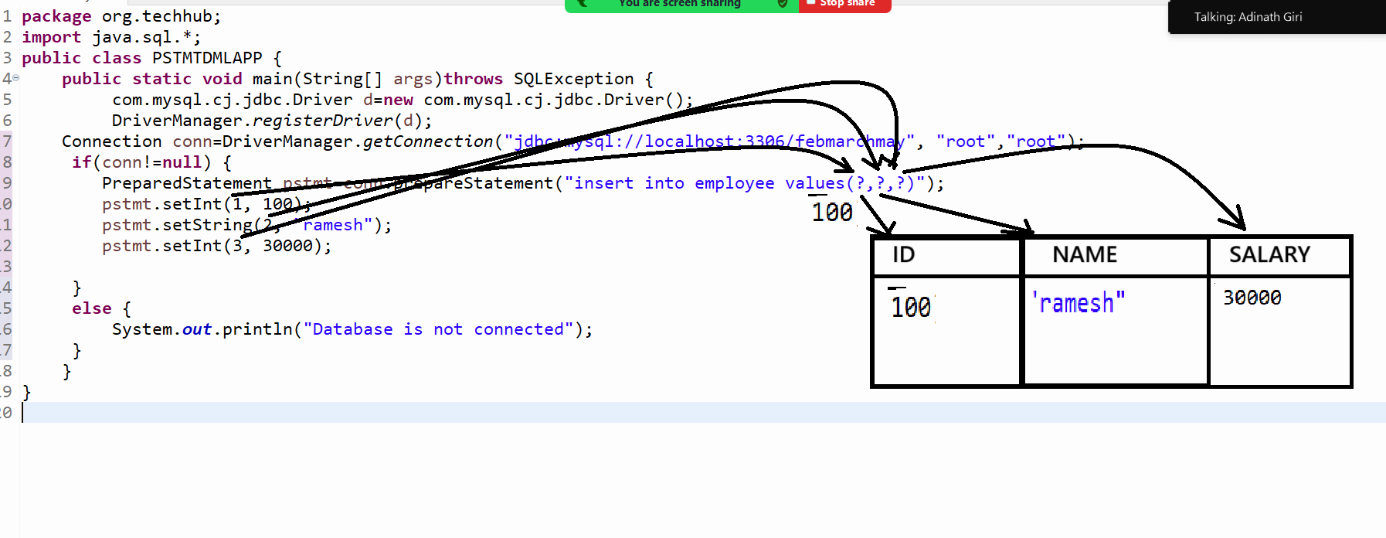

c) Use its executeUpdate() and executeQuery() method
int executeUpdate(): this method can execute the all DML operation except select and if operation executed successfully return 1 otherwise return 0
ResultSet executeQuery(): this method can execute the select query and store its data in ResultSet interface

Example: we want to accept name id and salary of employee from keyboard and store in database table.
package org.techhub;
import java.sql.*;
import java.util.*;
public class PSTMTDMLAPP {
public static void main(String[] args)throws SQLException {
com.mysql.cj.jdbc.Driver d=new com.mysql.cj.jdbc.Driver();
DriverManager.registerDriver(d);
Connection conn=DriverManager.getConnection("jdbc:mysql://localhost:3306/febmarchmay", "root","root");
if(conn!=null) {
Scanner xyz = new Scanner(System.in);
System.out.println("Enter name id and salary of employee");
String name=xyz.nextLine();
int id=xyz.nextInt();
int salary=xyz.nextInt();
PreparedStatement pstmt=conn.prepareStatement("insert into employee values(?,?,?)");
pstmt.setInt(1,id);
pstmt.setString(2, name);
pstmt.setInt(3, salary);
int value=pstmt.executeUpdate();
if(value>0) {
System.out.println("Record Save Success.................");
}
else {
System.out.println("Some problem is there..................");
}
}
else {
System.out.println("Database is not connected");
}
}
}

Example: WAP to delete the employee record by using its id using PreparedStatement interface
package org.techhub;
import java.sql.*;
import java.util.*;
public class DeleteRecordByIdApp {
public static void main(String[] args)throws SQLException {
Scanner xyz = new Scanner(System.in);
com.mysql.cj.jdbc.Driver d=new com.mysql.cj.jdbc.Driver();
DriverManager.registerDriver(d);
Connection conn=DriverManager.getConnection("jdbc:mysql://localhost:3306/febmarchmay","root","root");
if(conn!=null) {
System.out.println("Enter employee id");
int empid=xyz.nextInt();
PreparedStatement stmt=conn.prepareStatement("delete from employee where id=?");
stmt.setInt(1, empid);
int value=stmt.executeUpdate();
if(value>0)
{
System.out.println("Employee Record Deleted Successfully..............");
}
else {
System.out.println("Some problem is there............................");
}
}
else {
System.out.println("Database is not connected");
}
}

}
Example: WAP to change name and salary of employee using its id.
________________________________________________________________________
package org.techhub;
import java.sql.*;
import java.util.*;
public class DeleteRecordByIdApp {
public static void main(String[] args)throws SQLException {
Scanner xyz = new Scanner(System.in);
com.mysql.cj.jdbc.Driver d=new com.mysql.cj.jdbc.Driver();
DriverManager.registerDriver(d);
Connection conn=DriverManager.getConnection("jdbc:mysql://localhost:3306/febmarchmay","root","root");
if(conn!=null) {
System.out.println("Enter name id and salary of employee");
String name=xyz.nextLine();
int id=xyz.nextInt();
int sal=xyz.nextInt();
PreparedStatement pstmt=conn.prepareStatement("update employee set name=?,salary=? where id=?");
pstmt.setString(1, name);
pstmt.setInt(2, sal);
pstmt.setInt(3,id);
int value=pstmt.executeUpdate();
if(value>0) {
System.out.println("Record updated successfully...................");
}
else {
System.out.println("Some problem is there...........................");
}
}
else {
System.out.println("Database is not connected");
}
}

}
Example: WAP to fetch data from database table using PreparedStatement interface
_________________________________________________________________________
package org.techhub;
import java.sql.*;
import java.util.*;
public class DeleteRecordByIdApp {
public static void main(String[] args)throws SQLException {
Scanner xyz = new Scanner(System.in);
com.mysql.cj.jdbc.Driver d=new com.mysql.cj.jdbc.Driver();
DriverManager.registerDriver(d);
Connection conn=DriverManager.getConnection("jdbc:mysql://localhost:3306/febmarchmay","root","root");
if(conn!=null) {
PreparedStatement stmt=conn.prepareStatement("select *from employee");
ResultSet rs=stmt.executeQuery();
while(rs.next()) {
System.out.println(rs.getInt("id")+"\t"+rs.getString("name")+"\t"+rs.getInt("salary"));
}
}
else {
System.out.println("Database is not connected");
}
}
}

How to use where clause in Select Query using PreparedStatement interface
____________________________________________________________________________
if we use where clause in select query using PreparedStatement interface then after where clause parameter should pass using PreparedStatement object and before from parameter should access using ResultSet and its getXXX() method

Example: we want to fetch name and salary of employee by using id and name

package org.techhub;
import java.sql.*;
import java.util.*;
public class DeleteRecordByIdApp {
public static void main(String[] args)throws SQLException, ClassNotFoundException {
Scanner xyz = new Scanner(System.in);
Class.forName("com.mysql.cj.jdbc.Driver");
Connection conn=DriverManager.getConnection("jdbc:mysql://localhost:3306/febmarchmay","root","root");
if(conn!=null) {
System.out.println("Enter name and id of employee");
String name=xyz.nextLine();
int empid=xyz.nextInt();
PreparedStatement stmt=conn.prepareStatement("select name,salary from employee where name=? and id=?");
stmt.setString(1,name);
stmt.setInt(2, empid);
ResultSet rs=stmt.executeQuery();
while(rs.next()) {
System.out.println(rs.getString("name")+"\t"+rs.getInt("salary"));
}
}
else {
System.out.println("Database is not connected");
}
}
}

How to store the csv file in data in database table
_________________________________________________________________________________

Q. What is CSV?
___________________________________________________________________________
CSV stands for comma separated file basically it is like as excel format, but the benefit of CSV file is it is platform independent means we can use CSV format on any operating system as well as it is simple text document so not need to install any external software open this file.

Q. Why use CSV File?
_________________________________________________________________________
If we want to upload bulk data in database table, then we can use CSV format.

How to create .csv file?
_____________________________________________________________________________
Steps.
a) Open the any text editor like as notepad
b) Store data in notepad file by separated comm.
c) Save this file using .csv extension

Example: Consider we want to store 100 employee data at time in database table using csv file
emp.csv
________________________________________________________________
1, ram, 1000
2, shyam, 2000
3, ganesh, 3000

Steps to load the .csv file in database table
__________________________________________________________________________________
a) Read CSV file using BufferedReader class
package org.techhub;
import java.sql.*;
import java.io.*;
public class LoadingCSVAPP {
public static void main(String[] args) throws SQLException,IOException{
FileReader fr = new FileReader("D:\\feb2024\\emp.csv");
BufferedReader br=new BufferedReader(fr);
String line;
while((line=br.readLine())!=null) {
System.out.println(line);
}
}
}
B) Separate string data by using comma
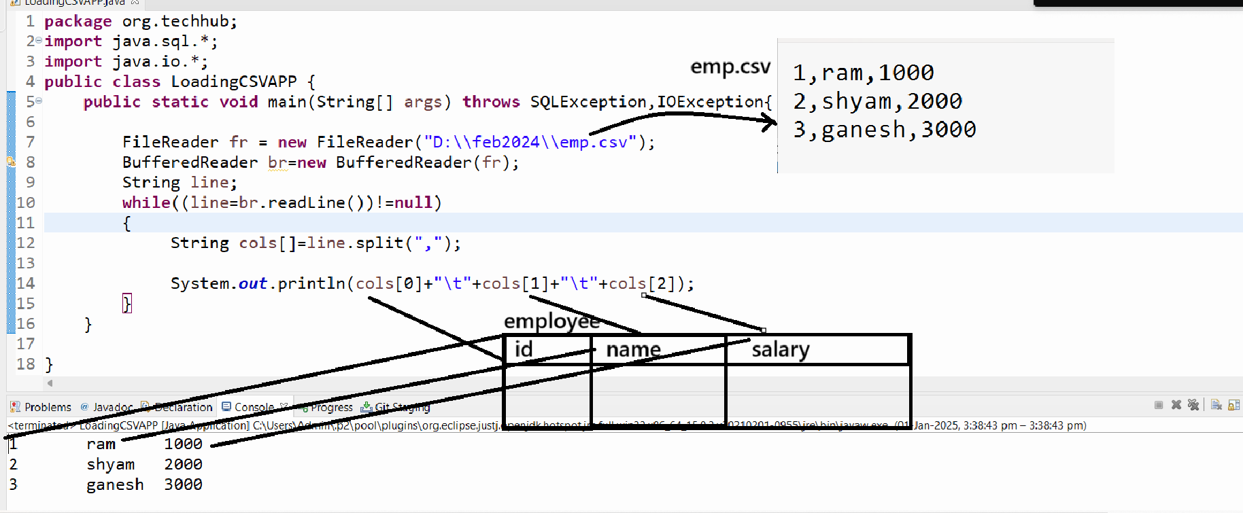

Example with source code
package org.techhub;

import java.sql.*;
import java.io.*;

public class LoadingCSVAPP {
public static void main(String[] args) throws SQLException, IOException {

FileReader fr = new FileReader("D:\\feb2024\\emp.csv");
BufferedReader br = new BufferedReader(fr);
String line;
Connection conn = DriverManager.getConnection("jdbc:mysql://localhost:3306/febmarchmay", "root", "root");
if (conn != null) {
int value=0;
while ((line = br.readLine()) != null) {
String cols[] = line.split(",");
PreparedStatement stmt=conn.prepareStatement("insert into employee values(?,?,?)");
stmt.setInt(1, Integer.parseInt(cols[0]));
stmt.setString(2, cols[1]);
stmt.setInt(3,Integer.parseInt(cols[2]));
value=stmt.executeUpdate();
}
if(value>0) {
System.out.println("File uploaded successfully.................");
}
else {
System.out.println("Some problem in file uploading");
}
} else {
System.out.println("Database is not connected");
}
}

}

How to access the database credential using .properties file
____________________________________________________________________________

Q. What are properties?
_____________________________________________________________________________
Properties file is configuration file in java where we can configure data in the form of name and value pair or key and value pair
Means using key we can access values in java application

Q. What is the use of .properties in java application?
______________________________________________________________________________
To write configuration or java configuration required for java application
Example: Suppose consider if we think about JDBC Application if we write username and password in java code and create setup of java application and hand application to end user and if user want to change username and password in future then we need to perform change in java code and recompile java code and re-create setup of application so it is very complicated task so better way you can configure your username and password in .properties file as per our example and access the properties file data in java application so when user want to change data then not need to perform change in java code just we can perform change in .properties file then change automatically get reflected in java application

How to create properties file
Steps
________________________________________
a). Create file with .properties extension
Example: db.properties
b) Store data in .properties file using key and value pair.
key=value
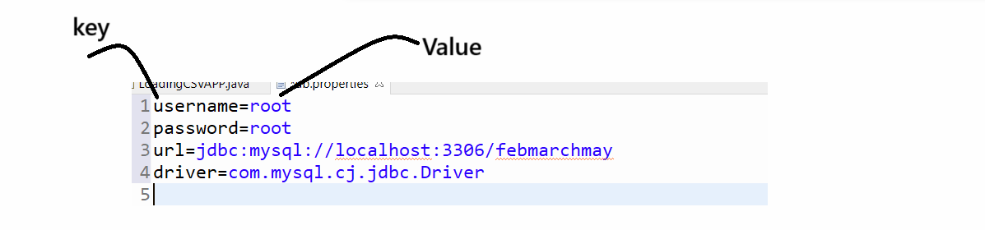
Once we create properties we can read property using java code

How we can read properties using java code
_____________________________________________________________
a) Create Object of FileInputStream class and give .properties file path

package org.techhub;
import java.sql.*;
import java.io.*;
public class LoadingCSVAPP {
public static void main(String[] args) throws SQLException, IOException {
FileInputStream fin=new FileInputStream("D:\\Springbootapp\\JDBCPSTMTAPP\\src\\db.properties");
}
}
b) Create Object of Properties class
package org.techhub;

import java.sql.*;
import java.util.Properties;
import java.io.*;

public class LoadingCSVAPP {
public static void main(String[] args) throws SQLException, IOException {

FileInputStream fin=new FileInputStream("D:\\Springbootapp\\JDBCPSTMTAPP\\src\\db.properties");
Properties p =new Properties();
}

}
C) call load() method of Properties class and pass FileInputStream object in it.
package org.techhub;

import java.sql.*;
import java.util.Properties;
import java.io.*;

public class LoadingCSVAPP {
public static void main(String[] args) throws SQLException, IOException {

FileInputStream fin=new FileInputStream("D:\\Springbootapp\\JDBCPSTMTAPP\\src\\db.properties");
Properties p =new Properties();
p.load(fin);

}

}
D) access property data using getProperty() method of Properties class
Syntax: String value=propertyref.getProperties(String key);
package org.techhub;

import java.sql.*;
import java.util.Properties;
import java.io.*;

public class LoadingCSVAPP {
public static void main(String[] args) throws SQLException, IOException {

FileInputStream fin=new FileInputStream("D:\\Springbootapp\\JDBCPSTMTAPP\\src\\db.properties");
Properties p =new Properties();
p.load(fin);
String un=p.getProperty("username");
String up=p.getProperty("password");
String uu=p.getProperty("url");
String dv=p.getProperty("driver");
System.out.println(un+"\t"+up+"\t"+uu+"\t\t"+dv);
}

}

package org.techhub;

import java.sql.*;
import java.util.Properties;
import java.io.*;
public class LoadingCSVAPP {
public static void main(String[] args) throws SQLException, IOException, ClassNotFoundException {
FileInputStream fin=new FileInputStream("D:\\Springbootapp\\JDBCPSTMTAPP\\src\\db.properties");
Properties p =new Properties();
p.load(fin);
String un=p.getProperty("username");
String up=p.getProperty("password");
String uu=p.getProperty("url");
String dv=p.getProperty("driver");
Class.forName(dv);
Connection conn=DriverManager.getConnection(uu,un,up);
if(conn!=null) {
System.out.println("Database is connected");
}
else {
System.out.println("Database is not connected");
}
}
}

How to store text file in database
_______________________________________________________________________________
If we want to store text file in database we have following steps.
a) Add java.io package in application
_______________________________________________________________________________
import java.io.*;
b) Create table and mark column type as text
_______________________________________________________________________
if we want to store text file in column then your column type should be text.
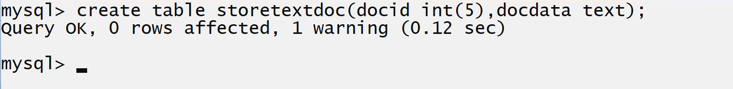
c) Read text file from system using Reader class
Example with source code
package org.techhub;
import java.io.*;
import java.sql.DriverManager;
import java.util.Properties;
import java.sql.*;
public class StoreTextFileApplication {
public static void main(String[] args)throws Exception {
Properties p = new Properties();
p.load(new FileInputStream(new File("").getAbsolutePath()+"\\src\\db.properties"));
Class.forName(p.getProperty("driver"));
Connection conn=DriverManager.getConnection(p.getProperty("url"),p.getProperty("username"), p.getProperty("password"));
if(conn!=null) {
System.out.println("Database is connected");
File f=new File("D:\\feb2024\\stream.txt");
FileReader fr=new FileReader(f);
}
else {
System.out.println("Database is not connected");
}
}
}

d) Call the setCharacterStream () method of PreparedStatement interface
__________________________________________________________________________
void setCharacterStream(int index,Reader,int length): this method is used for store reader object in database table means store document column whose data type is text if we think about MYSQL database and clob if we think about Oracle database.

int index: this parameter indicates the index of database table or index query for column
Reader: this parameter indicate reference of reader in which file path is present
int length: this parameter indicates length of data or file which we want to store in database table.

example with source code
package org.techhub;
import java.io.*;
import java.sql.DriverManager;
import java.util.Properties;
import java.sql.*;
public class StoreTextFileApplication {
public static void main(String[] args) throws Exception {
Properties p = new Properties();
p.load(new FileInputStream(new File("").getAbsolutePath() + "\\src\\db.properties"));
Class.forName(p.getProperty("driver"));
Connection conn = DriverManager.getConnection(p.getProperty("url"), p.getProperty("username"),
p.getProperty("password"));
if (conn != null) {
System.out.println("Database is connected");
File f = new File("D:\\feb2024\\stream.txt");
FileReader fr = new FileReader(f);
PreparedStatement stmt = conn.prepareStatement("insert into storetextdoc values(?,?)");
stmt.setInt(1, 101);
stmt.setCharacterStream(2, fr, f.length());
int value = stmt.executeUpdate();
if (value > 0) {
System.out.println("Record save in database table");
} else {
System.out.println("Some problem is there...............");
}

} else {
System.out.println("Database is not connected");
}
}
}

How to read text document from database table
____________________________________________________________________________
if we want to read text document from database table we have to use getCharacterStream() method of ResultSet interface

Syntax: Reader getCharacterStream(int index): this method is used for read text document using its index and return reference of Reader class from java.io package.

Example with source code
package org.techhub;
import java.io.*;
import java.sql.*;
public class ReadTextDocApplication {
public static void main(String[] args)throws Exception {

Connection conn=DriverManager.getConnection("jdbc:mysql://localhost:3306/febmarchmay","root","root");
if(conn!=null)
{
PreparedStatement stmt=conn.prepareStatement("select *from storetextdoc");
ResultSet rs=stmt.executeQuery();
System.out.println("====================================================");
while(rs.next()) {
Reader r=rs.getCharacterStream(2);
BufferedReader br=new BufferedReader(r);
String line="";
System.out.println("File Data id is "+rs.getInt(1));
while((line=br.readLine())!=null) {
System.out.println(line);
}
System.out.println("======================================");
}
}
else {
System.out.println("Database is not connected");
}
}
}

How to store image in database table
______________________________________________________________________________
If we want to store image in database table, we have some following steps.

a) Create table using blob data type
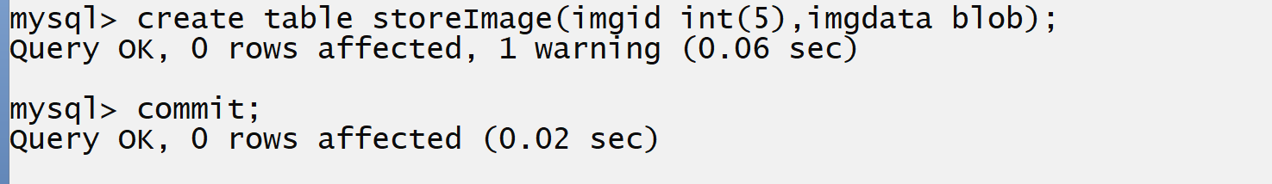
b) Read image file from system using stream class
______________________________________________________________
If we want to read image, we can use FileInputStream class
Sample code
package org.techhub;
import java.io.*;
import java.sql.DriverManager;
import java.sql.*;
public class StoreImageApplication {

public static void main(String[] args)throws Exception {
Connection conn=DriverManager.getConnection("jdbc:mysql://localhost:3306/febmarchmay","root","root");
if(conn!=null) {
File f=new File("C:\\Users\\Admin\\Pictures\\Screenshots\\a.png");
FileInputStream fin=new FileInputStream(f);

}
else {
System.out.println("Not Connected");
}
}

}

c) Call setBinaryStream() method of PreparedStatement interface
_________________________________________________________________
if we want to store image in database table we have to use
void setBinaryStream(int index,InputStream,int length):
int index: this parameter indicate the index in which we want to store column data
InputStream: reference of file which we want to send in database table
int length: this parameter indicate actual size of data we want to store in file.

Example with source code
package org.techhub;

import java.io.*;
import java.sql.DriverManager;
import java.sql.*;

public class StoreImageApplication {

public static void main(String[] args) throws Exception {
Connection conn = DriverManager.getConnection("jdbc:mysql://localhost:3306/febmarchmay", "root", "root");
if (conn != null) {
File f = new File("C:\\Users\\Admin\\Pictures\\Screenshots\\a.png");
FileInputStream fin = new FileInputStream(f);
PreparedStatement stmt = conn.prepareStatement("insert into storeimage values(?,?)");
stmt.setInt(1, 101);
stmt.setBinaryStream(2, fin, f.length());
int value = stmt.executeUpdate();
if (value > 0) {
System.out.println("Image store in database table");
} else {
System.out.println("Some problem is there................");
}
} else {
System.out.println("Not Connected");
}
}
}
How to read image from database table and store in hard disk
__________________________________________________________________________
package org.techhub;
import java.sql.*;
import java.io.*;
public class ImageReadingApplication {
public static void main(String[] args)throws Exception {
Connection conn=DriverManager.getConnection("jdbc:mysql://localhost:3306/febmarchmay","root","root");
if(conn!=null)
{ PreparedStatement stmt=conn.prepareStatement("select *from storeImage");
ResultSet rs=stmt.executeQuery();
while (rs.next()) {
InputStream inf=rs.getBinaryStream(2);
FileOutputStream fout=new FileOutputStream("D:\\feb2024\\a.png");
int data;
while((data=inf.read())!=-1) {
fout.write(data);
}
fout.close();
inf.close();
System.out.println("Image Retrieve Successfully..............");
}
}
else {
System.out.println("Not Connected");
}
}
}

How to call procedure using JDBC
____________________________________________________________________
Q. before calling procedure using JDBC we should have to know
What is Procedure?
_____________________________________________________________
Procedure is a stored program in database which is used for writing the SQL query logics and we can reuse SQL logics more than one time by calling procedure.
How to Create Procedure in database?
______________________________________________________________________
If we want to create procedure in database, we have following syntax

Syntax: delimiter character
create procedure procedurename(IN | OUT | IN OUT variablename datatype(size))
begin
write here your logics
end
character

Description of above syntax
______________________________________________________________________________
delimiter character: delimiter indicate the end of character for SQL statement and by default it is semi colon but when we use procedure, function or trigger then we can set delimiter character except semi colon.

create procedure procedurename: create procedure is used for creating the procedure in database like as table.
If we think about procedure, it contains three types of parameters
IN: this is the default parameter in procedure using this parameter we can accept data in procedure from calling point.
OUT: this parameter helps us we can return data from procedure at calling point
IN OUT: we can single parameter for input and output purpose

Example: we want to create procedure to store data in employee table.
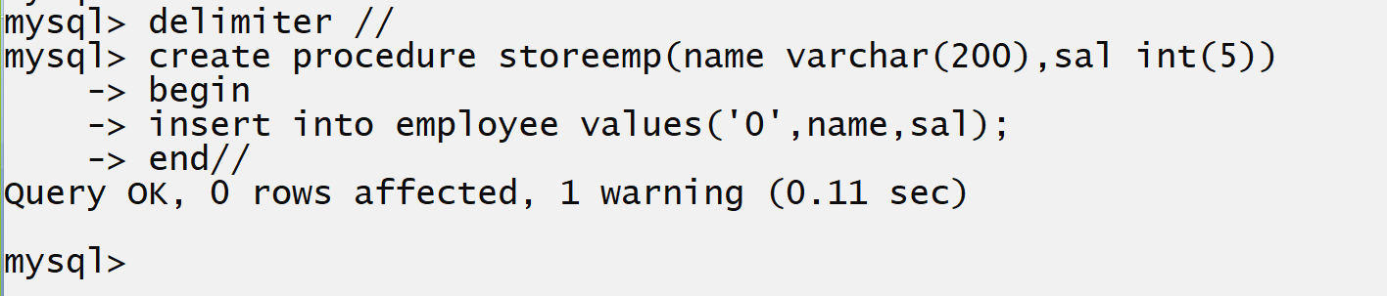

Once we create procedure, we can reuse the same procedure again and again and for that we required to call procedure

Syntax for calling procedure
_____________________________________________________________________
Syntax: call procedurename(parameters);
How to call procedure using JDBC?
_________________________________________________________________________
If we want to call procedure using JDBC we have interface name as CallableStatement interface
if we want to create reference of CallableStatement interface we have prepareCall() method of Connection interface.

Syntax: CallableStatement ref =connref.prepareCall({call procedurename(?,?,?,………?)});

Sample code
__________________________________________________________________________
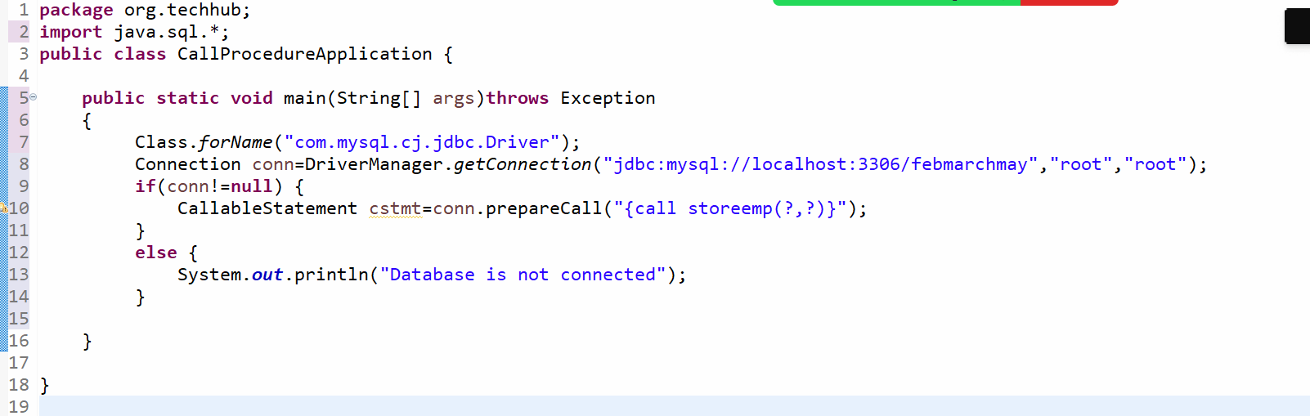
If we think about above procedure we pass or use? in procedure as parameter or IN parameter to procedure and if we want to pass parameter values to procedure we have setXXX() method of PreparedStatement and PreparedStatement interface is parent of CallableStatement means all methods of PreparedStatement is present in CallableStatement shown in following

Example with source code
package org.techhub;
import java.sql.*;
import java.util.*;
public class CallProcedureApplication {

public static void main(String[] args)throws Exception
{
Class.forName("com.mysql.cj.jdbc.Driver");
Connection conn=DriverManager.getConnection("jdbc:mysql://localhost:3306/febmarchmay","root","root");
if(conn!=null) {
Scanner xyz = new Scanner(System.in);
System.out.println("Enter name and salary of employee");
String name=xyz.nextLine();
int sal=xyz.nextInt();
CallableStatement cstmt=conn.prepareCall("{call storeemp(?,?)}");
cstmt.setString(1, name);
cstmt.setInt(2,sal);

}
else {
System.out.println("Database is not connected");
}

}

}
Once we pass parameter to procedure we can execute the procedure and if we want to execute the procedure we have execute() method of CallableStatement and this method return false when procedure run successfully otherwise return true.

package org.techhub;
import java.sql.*;
import java.util.*;
public class CallProcedureApplication {

public static void main(String[] args)throws Exception
{
Class.forName("com.mysql.cj.jdbc.Driver");
Connection conn=DriverManager.getConnection("jdbc:mysql://localhost:3306/febmarchmay","root","root");
if(conn!=null) {
Scanner xyz = new Scanner(System.in);
System.out.println("Enter name and salary of employee");
String name=xyz.nextLine();
int sal=xyz.nextInt();
CallableStatement cstmt=conn.prepareCall("{call storeemp(?,?)}");
cstmt.setString(1, name);
cstmt.setInt(2,sal);
boolean b=cstmt.execute();
if(!b) {
System.out.println("Procedure executed successfully......");
}
else {
System.out.println("Some problem is there...................");
}
}
else {
System.out.println("Database is not connected");
}

}
}

How to get out parameter using Procedure?
________________________________________________________________________________
If we want to get out parameter using a procedure we have following steps.

1) Declare out parameter in procedure which we want to return at or use at calling point.
2) Copy data in out parameter using INTO keyword
3) Use the out parameter at procedure calling point
4. Display the output parameter data.

Example: we want to get salary of employee using its id.
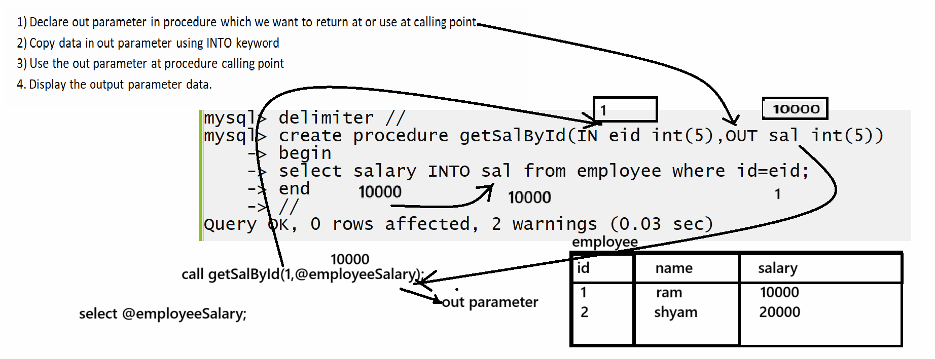

How to call procedure with OUT parameter using JDBC
________________________________________________________________________
Steps.
__________________________________________________________________
1. Create reference of CallableStatement and call procedure and pass parameter
2. Register the output with its datatype using CallableStatement object
3. Call the getXXX() method for getting value of OUT parameter according out parameter data type

Example with source code
package org.techhub;
import java.sql.*;
public class GetOutParameterUsingProcedureApplication {
public static void main(String[] args)throws Exception {
Connection conn=DriverManager.getConnection("jdbc:mysql://localhost:3306/febmarchmay","root","root");
if(conn!=null) {
CallableStatement cstmt=conn.prepareCall("{call getSalById(?,?)}");
cstmt.setInt(1, 18);//in parameter cstmt.registerOutParameter(2,Types.INTEGER);//we register out parameter of type integer and which second parameter
boolean b=cstmt.execute();
if(!b) {
int outputData=cstmt.getInt(2);//get out parameter and display it
System.out.println("Employee Salary is "+outputData);
}
else {
System.out.println("Procedure not executed successfully.............");
}
}
else {
System.out.println("Database is not connected");
}
}

}

5. Close the connection

